In this project we attempt to create a simple nmap scanning tool using python in our kali linux virtual machine. Lets break down each step one by one.

Step1: We first open terminal and then type the command gedit nmapscanner.py to open a text editor with the extension .py for python.

Step2: We now type in the following python script.

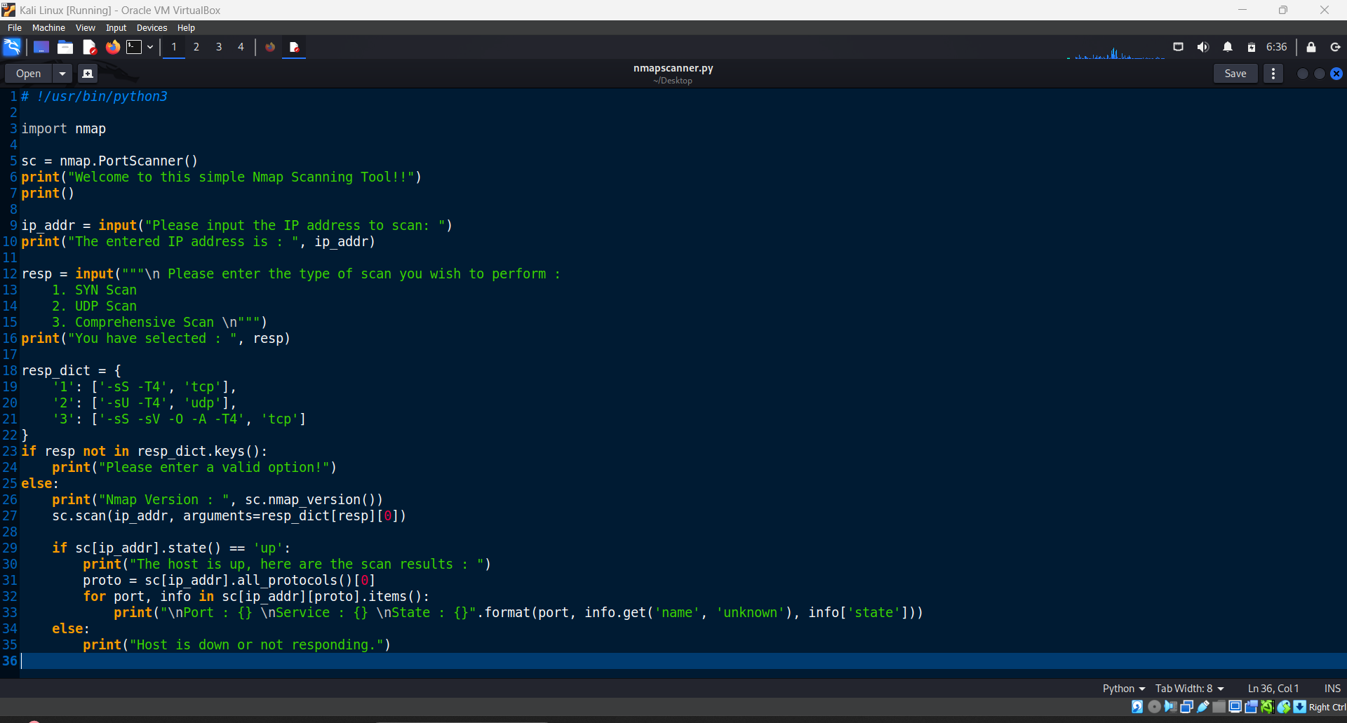

Step 3: We now save this, open our meta2 machine and obtain its IP

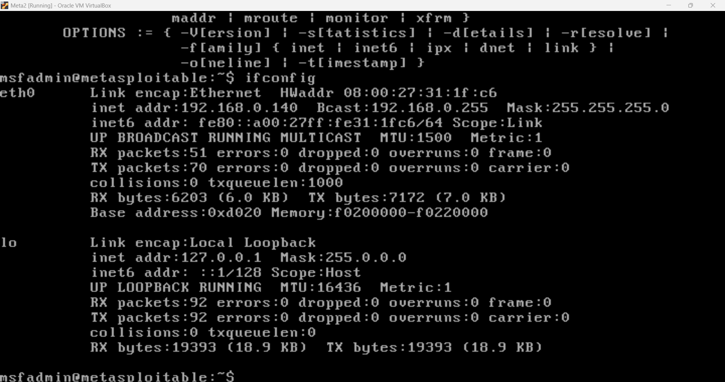

Step 4: We now return to the terminal and run the command python3 nmapscanner.py to run the python file. Enter the IP of the meta2 machine we obtained earlier and then select the type of scan we want to perform, 1 for a SYN Scan, 2 for UDP scan and 3 for Comprehensive Scan.

